PRACTICAL NO 03
pip install pandas
py -m pip install pandas scikit-learn

code

import pandas as pd
import matplotlib.pyplot as plt
import numpy as np
from sklearn.tree import DecisionTreeClassifier

# Rainfall dataset
rainfall = [799, 1174.8, 865.1, 1334.6, 635.4, 918.5, 685.5, 998.6, 784.2, 985, 882.8, 1071]

# Generate monthly date range for 2012
dates = pd.date_range(start="2012-01-01", periods=12, freq="ME")

# Convert rainfall data into a time series
rainfall_series = pd.Series(rainfall, index=dates)

# Convert data into 2D array for classification
X = np.array(rainfall).reshape(-1, 1)

# Create class labels using np.where()
# 0 = Low (<800), 1 = Medium (800-999), 2 = High (>=1000)
y = np.where(X < 800, 0,
np.where(X < 1000, 1, 2)).ravel()

# Apply Decision Tree Classification algorithm
model = DecisionTreeClassifier()
model.fit(X, y)

# Classification happens here
print("Classification done")

# Plot rainfall time series
plt.plot(rainfall_series)
plt.title("Monthly Rainfall - 2012")
plt.xlabel("Month")
plt.ylabel("Rainfall (mm)")

# Save and display the graph
plt.savefig("rainfall.png")
plt.show()

PRACTICAL NO 04
py -m pip install matplotlib

code
import pandas as pd
import matplotlib.pyplot as plt
from sklearn.datasets import load_iris
from sklearn.cluster import KMeans
from sklearn.preprocessing import StandardScaler
from sklearn.metrics import silhouette_score
# 1. Load Dataset
iris = load_iris()
X = pd.DataFrame(iris.data, columns=iris.feature_names)
# 2. Feature Scaling (important for clustering)
scaler = StandardScaler()
X_scaled = scaler.fit_transform(X)
# 3. Apply K-Means Clustering
kmeans = KMeans(n_clusters=3, random_state=42)
kmeans.fit(X_scaled)
# 4. Get Cluster Labels
clusters = kmeans.labels_
# 5. Evaluate Clustering
sil_score = silhouette_score(X_scaled, clusters)
print("Silhouette Score:", sil_score)
# 6. Add Clusters to DataFrame
X['Cluster'] = clusters
print(X.head())
# 7. Visualize Clusters (2D using first two features)
plt.figure(figsize=(8,6))
plt.scatter(X_scaled[:, 0], X_scaled[:, 1], c=clusters, cmap='viridis')
plt.title("K-Means Clustering (Iris Dataset)")
plt.xlabel("Feature 1")
plt.ylabel("Feature 2")
plt.colorbar(label='Cluster')
plt.show()

PRACTICAL NO 05

Code
#Import required libraries
import numpy as np
import pandas as pd
import matplotlib.pyplot as plt
from sklearn.linear_model import LinearRegression

#Create data
x=np.array([151, 174, 138, 186, 128, 136, 179, 163, 152, 131]).reshape(-1, 1)
y=np.array([63, 81, 56, 91, 47, 57, 76, 72, 62, 48])

#Build linear regression model
model=LinearRegression()
model.fit(x, y)

#Predict value for x = 140
prediction=model.predict([[140]])
print("Predicted value for x=140:", prediction[0])

#Print model parameters
print("Intercept:", model.intercept_)
print("Slope:", model.coef_[0])

#Plot graph

plt.scatter(x, y, color='blue')
plt.plot(x, model.predict(x), color='red')
plt.title("Weight & Height Regression")
plt.xlabel("Height")
plt.ylabel("Weight")

plt.savefig("linearreg.png")
plt.show()

PRACTICAL NO 06
py -m pip install pydataset

code
import numpy as np
import matplotlib.pyplot as plt
import pandas as pd

from sklearn.linear_model import LogisticRegression
from sklearn.metrics import classification_report
from pydataset import data

# Load dataset
mtcars = data('mtcars')

# Select required columns
input_data = mtcars[['am', 'cyl', 'hp', 'wt']]
print(input_data.head())

# Define independent and dependent variables
X = input_data[['cyl', 'hp', 'wt']]
y = input_data['am']

# Build logistic regression model
log_model = LogisticRegression()
log_model.fit(X, y)

# Print coefficients
print("Intercept:", log_model.intercept_)
print("Coefficients:", log_model.coef_)
# Predict
y_pred = log_model.predict(X)
# Classification report
print(classification_report(y, y_pred))
# Plot using wt only
X1 = input_data[['wt']]
model2 = LogisticRegression()
model2.fit(X1, y)
plt.scatter(X1, y)
x_test = np.linspace(X1.min(), X1.max(), 100).reshape(-1, 1)
plt.plot(x_test, model2.predict_proba(x_test)[:, 1])
plt.xlabel("Weight")
plt.ylabel("Transmission (am)")
plt.title("Logistic Regression Curve")
plt.show()

PRACTICAL NO 07
pip install pandas

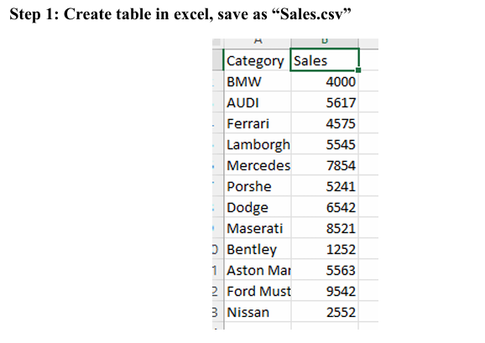
import pandas as pd
# Read CSV file
data = pd.read_csv("sales.csv")
print("Data from CSV file:")
print(data)
# Basic information
print("\nBasic Information:")
print(data.info())
# Statistical summary
print("\nStatistical Summary:")
print(data.describe())
# Calculated insights (from the same table)
total_sales = data["Sales"].sum()
average_sales = data["Sales"].mean()
highest_sales = data["Sales"].max()
lowest_sales = data["Sales"].min()
print("\nInsights:")
print("Total Sales:", total_sales)
print("Average Sales:", average_sales)
print("Highest Sales:", highest_sales)
print("Lowest Sales:", lowest_sales)
# Category-wise sales (still same table, just grouped)
category_sales = data.groupby("Category")["Sales"].sum()
print("\nCategory-wise Sales:")
print(category_sales)

